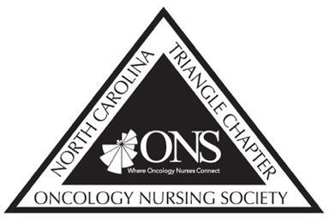
North Carolina Triangle Chapter of Oncology Nursing Society
Box 61682
Durham, NC 27705

NCTONS 2026 Oncology Conference Travel Award

TONS is committed to supporting our members in professional development and preparation to improve patient care and outcomes. To this end, we are offering competitive scholarships in the amount of $1500 to help members attend ONS Congress in 2026.

Details:

- Permitted use of funds:
  - Can be used to support conference registration, airfare, and accommodations.

- Process for receiving funds:
  - Scholarships will be awarded as reimbursements. Recipients will need to pay for conference expenses and then, within 30 days of attendance, submit original receipts to Allison Adler - allison.adler814@gmail.com. Recipients will then be mailed a reimbursement check for expenses up to the amount of $1500.

- Eligibility criteria:
  - Oncology Nursing Society member
  - NC TONS member
  - 2025 or 2026 dues paid (if applicable, as student members do not pay dues)
  - Must have attended one in person TONS meeting in the past year

- To apply:
  - Complete the attached application and send to kerri.dalton@duke.edu & Nancy.austin2@duke.edu by March 6, 2026.

- Application scoring:
  - Applications will be scored by three NC TONS board members on the following criteria:
    - Participation in NC TONS activities since becoming a member.
    - Service to NC TONS since becoming a member.
    - Evidence that applicant has identified how attending an oncology related conference will improve their professional development and contributions to improved oncology nursing care and patient outcomes.

- Award notifications
  - All applicants will be notified of funding decisions via email by March 13, 2026.

NCTONS 2026 Oncology Conference Travel Award Application

Name
ONS Member #
Date 2025/2026 TONS dues were paid

E-mail address

Phone number
Mailing Address

In 500 words or less please describe (1) your prior engagement with NC TONS, including service to NC TONS and (2) how conference attendance will advance your professional development and improve oncology nursing care and patient outcomes.

Signature: _______________________________ Date:__________________________

